MOTLHABI J.
IN THE HIGH COURT OF BOTSWANA
HELD AT LOBATSE

CASE NO: CVHGB-002489-23
In the matter between:

BBS BANK LIMITED Plaintiff

and

MORULAGANYI AUBREY MAROTSWANE Defendant

NOTICE OF SALE IN EXECUTION
_____________________________________________________________________

BE PLEASED TO TAKE NOTICE that pursuant to a Judgment of the above Honourable Court, the following property of the Defendant will be sold by public auction to the highest bidder by Deputy Sheriff UYAPO MAFIKA as follows:

DATE OF SALE: 30TH OCTOBER 2025;

PLACE : Tribal Lot 2538, Tlokweng

TIME: 10:30 hours;

PROPERTY TO BE SOLD: Defendant’s right, title and interest on a Certain Piece of Land being Tribal Lot 2538, Tlokweng, Measuring 942m² with developments thereon consisting of 2 bedroomed house, open plan kitchen, sitting room, bathroom and toilet, boundary wall with electric fence.

CONDITIONS OF SALE: May be inspected at the office of the Deputy Sheriff.

DATED AT GABORONE THIS 8TH DAY OF AUGUST 2025.

DEPUTY SHERIFF UYAPO MAFIKA
c/o MORIBAME MATTHEWS
Plaintiff’s Attorneys
Unit 6, Mowana Mews, Plot 74769,
Western Commercial Road, CBD
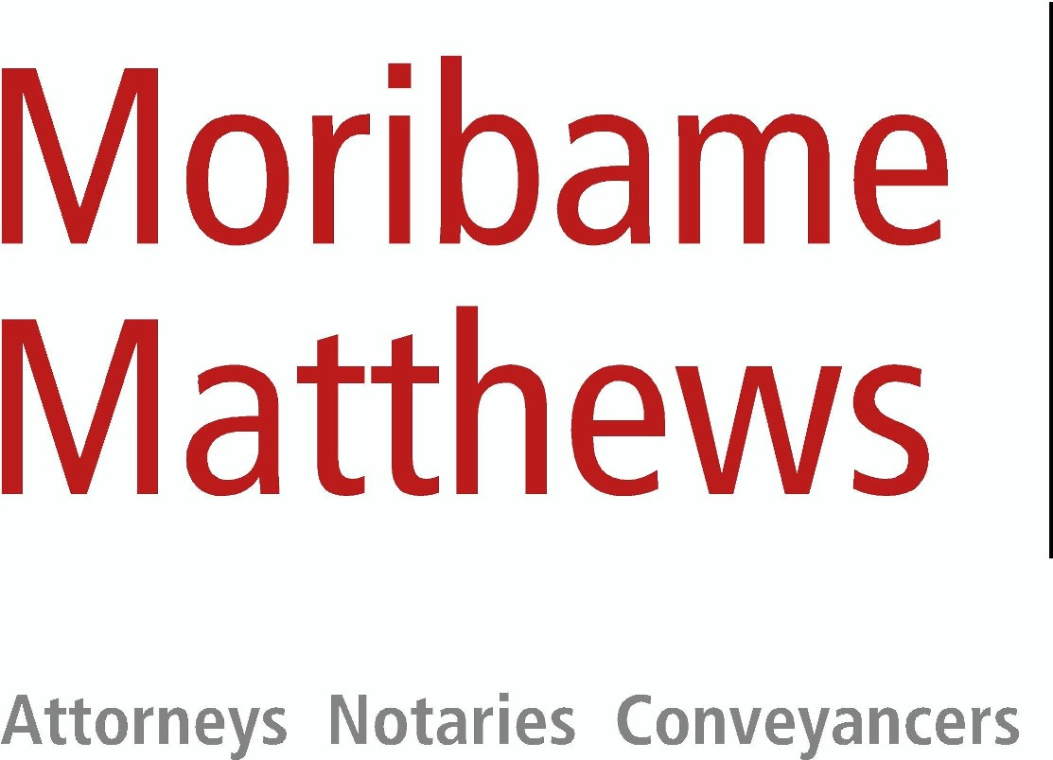
P O Box 46271
GABORONE
(Ref:KPM.mdl.006406)
Cell: 71696997

